**MCQs MTH302 for practice**

**Unit 1**



4.The probability density function of a random variable is given by

. The marginal distribution of is given by

1. (b) (c) (d)

Ans- (a)

5.Let be a random variable with ,

and . The conditional distribution of given is

1. (b) (c)

(d) .

Ans-(b)

6. Let be random variable with distribution function

Then

(A) 3/5 (B) 2/7 (C) 1/3 (D) 1

Q7. If the p.d.f of RV given as , then value of is

(A) (B) 10/9 (C) 5/8 (D) 9/7

Q8. , if then

(A) 1/3 (B) 1/2 (C) 5/6 (D) 2/3

Q9. Graph of is shown below. For what value of , can be used as pdf.

(A) 2/3 (B) 3/4 (C) 4/5 (D) ½

Q10. If pdf of random variable is given as , then value of distribution function at is

(A) 2/3 (B) 3/8 (C) 1/9 (D) ½

11.If X and Y denote the random variables, then which is not random variable?

1. None of the above

12.If then

1. 1/7
2. 2/7
3. 3/7
4. 4/7

ANS: A

13.Consider the statements:

1. For a discrete random variable X, the probability at a point is always vanish.
2. For a continuous random variable X, the probability at a point is always vanish.
3. The statement (i) is correct but not (ii).
4. The statement (ii) is correct but not (i).
5. The statements (i) and (ii) both are correct.
6. Neither the statement (i) nor (ii) is correct.

ANS: B

14.Statement: The variance

Reason: The variance is independent of change of origin.

1. Statement and reason both are correct.
2. Statement is correct but not the reason.
3. Reason is correct but not the statement.
4. Neither the statement nor the reason is correct.

ANS: C

15.The covariance is

16.



Ans c

17.If X is the discrete random variable and its pdf is given by f(x)= (x+2)/25 ,for X=1,2,3,4,5 , then cdf F(3)=

a)7/25 b) 12/25 c) 13/25 d) none of these

ans b

18.Find the probability of getting 2 club cards when 2 cards randomly drawn without replacement from well shuffled pack of 52 cards.

(a) 3/51

(b) 3/52

(c) 1/16

(d) None of these

19. Find the probability of getting 2 club cards when 2 cards randomly drawn with replacement from well shuffled pack of 52 cards.

(a) 3/51

(b) 3/52

(c) 1/16

(d) None of these

20.Find the probability of hitting the target when up to 3 fires are shot from gun whose probability of hitting the target is 0.4.

(a) 0.96

(b) 0.348

(c) 0.384

(d) None of these

21.A random variable *X* has a mean, and, of any unknown

Probability distribution. Then *P* (*|X −* 8*| ≥* 4)≤

(a) can not be predicted from limited data

(b) 9/16

(c) 16/9

(d) None of these

22.A random variable *X* has a mean , and , of any unknown

Probability distribution. Then *P*(*9< X <* 15) ≥

(a) can not be predicted from limited data

(b) 8/9

(c) 1/9

(d) None of these

23.

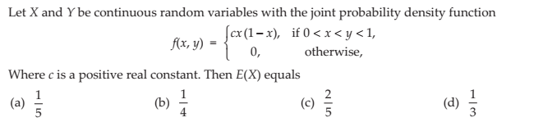

**Answer – (c)**

**24.**

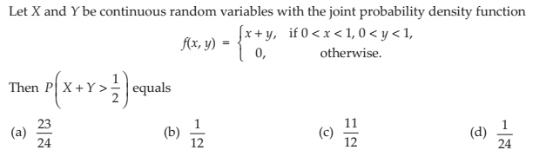

**Answer – (a)**

**Unit 2**

1. The correlation coefficient is 0.6. Find , where and .
2. 0.4 (b) 0.66 (c) 0.6 (d) 0.5

Ans – © 0.6

1. The covariance between and is 0.35, variance of is 1.1576 and variance of is 1.6075. Find the correlation coefficient.
2. 0.25 (b) 0.35 (c) 0.4 (d) 0.5

Ans- (a) 0.25





Q5. Using the following information on a bivariate data set, regression line of on is

(Here stands for standard deviation)

(A) (B)

(C) (D)

Q6. In the regression line , where   and , then value of is

(A) 1.75 (B) 1.60 (C) 2 (D) 2.5

Q7. Two regression lines are given as , then ratio of variances of to is

(A) (B) (C) (D)

Q8. Two regression lines are given as , then correlation coefficient between and is

(A) (B) (C) (D)

Q9. Angle between the regression lines for two uncorrelated variables is

(A) (B) (C) (D)

10.If two lines of regression are x+3y-5=0 and 4x+3y-8=0, then the correlation coefficient between x and y is

1. 1/3 b) ½ c) – ½ d) -3/5

Anc c

11.If the regression coefficients of regression equation of X on Y is 0.4 and of Y on X is 1.6, thrn the regression coefficient of U=3X on V=2Y is

a)0.4 b) 1.6 c) 1.066 d) 0.6

12. Two regression lines coincide if the correlation coefficient is

(A) (b) (c) (d) all are possible

ANS: D

13. If Two regression lines coincide then possible angle between them is/are

(A) and (b) 0 but not (c) but not 0 (d) None

ANS: C

14. The regression coefficient of X on Y is defined by

1. (b) (c) (d)

ANS: C

15. The product of two regression coefficients will be

(A) positive correlation only

(B) Negative correlation only

(C) May be positive or negative

(D) regression and correlation coefficient are not related.

ANS: C

16. The range of correlation and rank correlation coefficients is

(A) equal and positive but less than unity

(B) equal and negative but less than zero

(C) equal and lies between negative unity to positive unity

(A) not equal

ANS: C

17

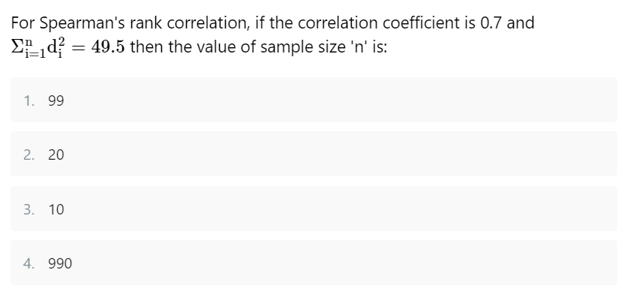

**Answer – 3**

**18**

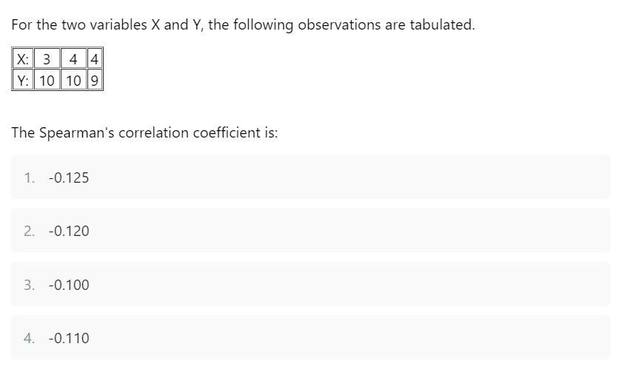

**Answer – 1**

**Unit 3**

1. If the mean and variance of a binomial random variable are 11.25 and 2.8125, respectively, find the number of trials.
2. 20 (b) 10 (c) 45 (d) 15

Ans - (d) 15

1. The mean and variance of a Binomial random variable are 2 and 1.2, respectively, find .
2. 0.0778 (b) 0.0102 (c) 0.778 (d) 0.25

Ans – (a) 0.0778





Q4. The probability of any one letter being delivered to the wrong house is 0.01. On a randomly selected day Peter delivers 1000 letters. Using a Poisson approximation, find the probability that Peter delivers 12 letters to the wrong house.

(A) 0.09478 (B) 0.06241 (C) 0.07729 (D) 0.02447

Q5. On the average, 1 in 800 computers crashes during a severe thunderstorm. A certain company had 4,000 working computers when the area was hit by a severe thunderstorm. Then the expected number of crashed computers is

(A) 10 (B) 20 (C) 5 (D) 15

6.Ten coins are tossed simultaneously. The probability of getting no head is

1. None

ANS: A

7.Select the correct option regarding mean and variance of Poisson distribution.

1. Mean is greater than variance.
2. Mean is less than variance.
3. Mean is equal to variance.
4. Mean and variance both are equal to 1.

ANS: C

8.Select the correct option regarding mean and variance of Negative Binomial distribution.

1. Mean is greater than variance.
2. Mean is less than variance.
3. Mean is equal to variance.
4. Mean and variance both are equal to 1.

ANS: B

9.If a company producing the large number of items, then the probability of 4 defective items can be obtained by

1. Bernoulli distribution
2. Binomial distribution
3. Negative Binomial distribution
4. Poisson distribution

ANS: C

1. The moment generating function of r.v. X can be obtained from
2. Expectation of X
3. Variance of X
4. Expectation of tx
5. Expectation of exponential (tX)

AND: D

11

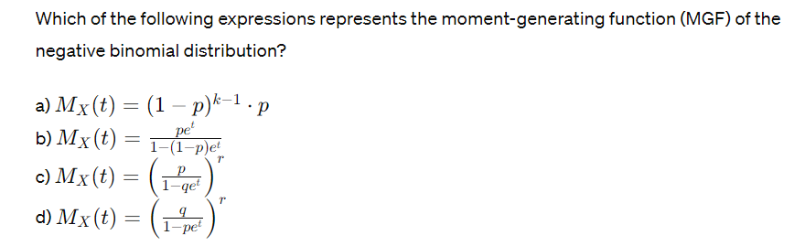

**Answer – c**

**12**

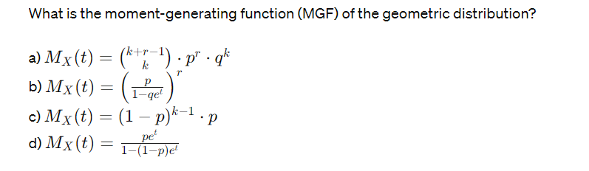

**Answer – d**

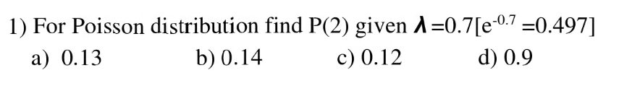



Anc c





1. 1 and 1 b) 1 and 2 c) 4 and 2 d) 2 and 1

Ans a

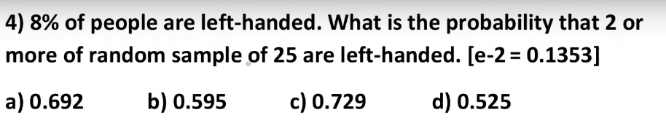



Ans b